**Advertisement System Cloud Based**

**PROJECT**

**REPORT**

***Submitted by***

**SHIVAM KUMAR**

**0080]**

**MCAR**

**[21**

*in partial fulfil*

*l*

*ment for the award of the degree*

*of*

**MASTER OF COMPUTER APPLICATIONS**

**WITH**

**SPECIALIZATION IN**

**STORAGE AND CLOUD TECHNOLOGY**

**DEPARTMENT OF**

**INFORMATION TECHNOLOGY**

**SCHOOL OF COMPUTER SCIENCE AND IT**

**JAIN KNOWLEDGE CAMPUS**

**JAYANAGAR 9**

**th**

**BLOCK BANGALORE**

**APRIL**

**-**

**2022**



**ADVERTISEMENT SYSTEM CLOUD BASED**

*Submitted by*

**SHIVAM KUMAR [21MCAR0080]**

*In partial fulfillment for the award of the degree of*

**MASTER OF COMPUTER APPLICATIONS**

**IN [STORAGE AND CLOUD TECHNOLOGY]**



**DEPARTMENT OF**

**INFORMATION TECHNOLOGY**

**JAIN KNOWLEDGE CAMPUS**

**JAYANAGAR 9TH BLOCK**

**BANGALORE**

**APRIL – 2022**



**DEPARTMENT OF**

**INFORMATION TECHNOLOGY**

**Jain Knowledge Campus**

**Jayanagar 9th Block Bangalore, 560069**

This is to certify that the project entitled

**ADVERTISEMENT SYSTEM CLOUD BASED**

***he bonafide record of project work done by***

**SHIVAM KUMAR [21MCAR0080]**

MCA with Specialization in [STORAGE AND CLOUD TECHNOLOGY ] during the year

**2020 -2022**

**-------------------------------------------- --------------------------------------**

##### Dr. Bhuvana J Dr. Bhuvana J

**Guide / Mentor Head, Department of Information Technology JAIN (Deemed to be University) JAIN (Deemed to be University)**

##### Dr. M N Nachappa

**Head, School of Computer Science & IT JAIN (Deemed to be University)**



**CERTIFICATE**

This is to certify that SHIVAM KUMAR USN No: 21MCAR0080 for the course of MCA in the Department of IT, School of Computer Science and IT has fulfilled the requirements prescribed for the MCA degree of the of JAIN (Deemed to be University).

The Project entitled, “STORAGE AND CLOUD TECHNOLOGY” was carried out under me direct supervision. No part of the dissertation was submitted for the award of any degree or diploma prior to this date.

##### **Dr Bhuvana J Dr. Bhuvana J**

**Guide / Mentor Head, Department of Information Technology JAIN (Deemed to Be University) JAIN (Deemed to be University)**

##### **Dr. M N Nachappa**

**Head, School of Computer Science & IT JAIN (Deemed to be University)**

### **Name of the Examiner Signature with Date**

1**. ........................................... ..........................................**

### 2. ........................................... ..........................................



**DECLARATION**

I affirm that the project work titled “ADVERTISEMENT SYSTME CLOUD BASED”, being submitted in partial fulfillment for the award of MASTER OF COMPUTER APPLICATIONS WITH SPECIALIZATION IN [STORAGE AND CLOUD TECHNOLOGY] is the original work carried out by me. It has not formed the part of any other project work submitted for award of any degree or diploma, either in this or any other University.

**SHIVAM KUMAR**

**[21MCAR0080]**



**ACKNOWLEDGEMENT**

I would like to acknowledge the following people, who have encouraged, guided and helped to accomplish my report to award my degree at The JAIN (Deemed to be University), Department of Information Technology, School of Computer Science and IT:

1. Thesis advisor and mentor Dr. Bhuvana J for guiding me through pivotal moments of my study and professional career and for always being there to make sure that my progress was reviewed, documented and acknowledged. His/her encouragement has been the greatest source of inspiration and confidence for me as a designer and artist.
2. Faculty and staff members of **Department of Information Technology** for sharing their expertise and for always showing their interests in my work.
3. Finally, I would like to thank my family, to whom this work is dedicated, for their support and encouragement during these years.

**Special Thanks to:**

* Dr. **M N Nachappa**, Head, School of Computer Science & IT, JAIN (Deemed to Be University)
* Dr. **Bhuvana J**, Head, Department of Information Technology, JAIN (Deemed to Be University)
* Dr. **Ganesh D**, Research Co-Ordinator, Department of Information Technology, JAIN (Deemed to Be University)
* Dr. **Kamalraj R**, Project Co-Ordinator, Department of Information Technology, JAIN (Deemed toBe University)

# ABSTRACT

The Advertising System Project is a complete online solution for advertisers who want to advertise their products on online media or websites. This project is developed for users who want to manage their online advertising from one place. This website is useful for employees and managers of advertising agencies to manage ads and view reports. This system provides a complete service for advertisers to present their products and services to the online marketplace. The advertising system will give the solution to all the problems related to online marketing. In this system, the user can create ads and also choose the website where he wants to show his ads online.

Now a day’s people are purchasing products online. Therefore, it is necessary for the company to advertise their product online. Online advertisement is a very complicated task we need a system to manage it. Advertisement management system helps to manage online advertisement. This system provides the complete service for advertiser to introduce their products and services into online market. Advertisement management system will give the solution of all problems that comes in online marketing. In this system user can create ads and can also select website where he want to show their ads online.

**TABLE OF CONTENTS**

**Contents Page no.**

CHAPTER 1 INTRODUCTION 1-3

1.1 OVERVIEW

* 1. OBJECTIVE
  2. SCOPE

CHAPTER 2 TECHNICAL FEASIBILITY 10-19

2.1 CLOUD COMPUTING

2.2 TOOLS/ENVIRONMENT USED

* + - PYTHON
    - DJANGO&HTML5(As front end)
    - SQLite 3 (As back end)

2.3 SOFTWARE REQUIRMENT SPECIFICATION

CHAPTER 3 DATABASES DESIGN 20-23

3.1 DATA DICTIONARY

3.2 ADMIN

3.3 DATABASES TABLES

CHAPTER 4 ER DIAGRAM AND DFD 20-25

4.1 DFD

4.2 ER DIAGRAMS

CHAPTER 5 FRONTEND DESIGN 26-29

5.1 Home Pages

5.2 About US

5.3 Contact Page

5.4 DETAILS

CHAPTER 6 TESTING 30-31

6.1 TESTING

6.2 LEVELS OF TESTING

* UNIT TESTING
* PERFORMANCE TESTING
* SYSTEM TESTING

CHAPTER 7 CODING 32-48

7.1 base.htm

7.2 detail.htm

7.3 about.htm

CHAPTER 8 FUTURE INHANCEMENT&CONCLUSION 49-54

8.1 References

8.2 Journal Proof-Published Papers

**CHAPTER 1**

**INTRODUCTION**

**1.1 Overview**

Advertisements are very necessary in order to market or promote the product of the particular product. Advertisements can be done through the online mode through the radio, television, social networking sites so that it will gain nice promotion. Online advertisement management system is an application that deals with maintaining the advertisements given by the customers to the company. There will be many customers with different advertisements for a particular company. Maintenance of all the data using pen paper work is a tedious job. So to reduce the manual effort, the online advertisement management application will be of great help. This application will be very useful to the advertising agencies and the managers to manage advertisements and to view reports.

### **1.2 OBJECTIVE**

The user interface must be simple and easy to understand. This will be one of the useful projects that one can work on and implement in real time application. The schedule of the advertisement must be given so that it can be put on online. This application can be implemented on the internet for the real time use. Advertisements are very necessary in order to gain profit for any organization or the company.

* Save cost

After computerized system is implemented less human force will be required to maintain the library thus reducing the overall cost.

* Save time

Librarian is able to search record by using few clicks of mouse and few search keywords thus saving his valuable time

* Ads Content Providers

Content Providers are independent Ads Agencies those helps advertiser to make their ads content and are connected with the advertisement management system

### **1.3 Scope**

Advertising has a very wide scope in marketing and in the social system. The scope of advertising is described on the basis of activities included under advertising and their forms and systems, objectives and functions. These include the

### **Introduces New Products**

It helps in introducing new products of companies in market. Advertising management through managing all advertising activities induce people to know about or try new products.

### **Create Wide Awareness**

Advertising management enables in creating wide awareness of brand products among audience. It is one through which company communicates all information regarding features, uses and advantages of product in market.

### **Increase Sales**

This process has a significant role in bringing up the sales of business organizations. Advertising activities facilitates mass sales for companies by reaching out to large customers and convincing them for buying it.

### **Enhances Goodwill**

Managing of all advertisement activities results in improving the brand’s image in market. It is the means through which companies show their presence among audience. Customers consider those brands superior that spend more on keeping them aware of their products.

### **Persuades Customers**

It assists in bringing more and more customers to business. Advertising management focuses on attracting large people by circulating well defined promotional message among customers. It convinces them to purchase the brand products by explaining them all benefits.

### **Faces Competition**

Advertising management process helps in facing the tough competition in market. There are large numbers of brand available selling same variety of products. Advertising activities enables business in differentiating their products among customers by explaining them all features and benefits over the other available products.

### **Generate Employment**

It has also led to generation of large number of employment opportunities in country. There are many people who are working in various advertisement agencies. Companies pay fees to these agencies for promotion of their products.

**CHAPTER 2 TECHNICAL FEASIBILITY**

**2.1 Cloud Computing**

Cloud Computing is a process of delivering/enabling scalable, expandable and almost perfectly elastic software services using internet technologies. It is a method of delivering [Software as a Service (SaaS)](https://www.hcltech.com/engineering-rd-services/software-product-engineering/software-as-a-service-saas), delivered in a pay-per-use basis. It provides self service capabilities to users with scalable features to increase usage on requirement.

The various cloud based services commonly offered are:

* Web Based Cloud Computing: Companies use the functionality provided by web services and do not have to develop a full application for their needs.
* [Infrastructure as a Service (IaaS)](https://www.hcltech.com/technology-qa/what-is-iaas): Organizations make use of the unlimited storage potential of the cloud infrastructure. They can expand and shrink their storage space as needed without having to worry about dedicated servers on site.
* Software as a Service (SaaS): It allows people to access the functionality of a particular software without worrying about storage or other issues.
* [Platform as a Service (PaaS)](https://www.hcltech.com/technology-qa/what-is-paas): Companies can run their applications on the cloud service’s platform without having to worry about maintaining hard drives and servers.
* Utility Services: Companies that need to store a lot of data can store all of their data remotely and can even create a virtual data center.
* Managed Services: These are applications used by the cloud service providers, such as anti-spam service.
* Service Commerce: It is the creation of a hub of applications that can be used by an organisation’s members. It provides organisations the applications they need along with the services they desire.

## ****EC2****

To begin with, ec2 stands for Amazon Elastic Compute Cloud. Amazon Ec2 is a basic virtual machine with customizable hardware components and an OS. The system allows you to run various virtual computers and manage the same with a single hardware.

Elastic Compute Cloud is the highly used and primary service system in the massive AWS ecosystem. The cloud system provides multiple features, for instance, it facilitates computing on-demand and scales the Computing capacity in the Amazon cloud system.

Amazon instances free you from making additional up-front investments for hardware. Also, no extra baggage of maintaining rented hardware. The all-in-one virtual hardware is easy to use and lets you create and run applications at a higher speed. Adapting Elastic Computing Cloud in AWS allows you to launch multiple virtual servers. It also provides the control to scaling up or scaling down in correspondence with the rate of the site traffic.

### 

### **EC2 Instance Type Breakdown**

#### **A Quick Summary**

EC2 instances come in the following categories:

* + [General Purpose](https://cloudacademy.com/blog/aws-ec2-instance-types-explained/#general): The most popular; used for web servers, development environments, etc.
  + [Compute Optimized](https://cloudacademy.com/blog/aws-ec2-instance-types-explained/#compute): Good for compute-intensive applications such as some scientific modeling or high-performance web servers.
  + [Memory Optimized](https://cloudacademy.com/blog/aws-ec2-instance-types-explained/#memory): Used for anything that needs memory-intensive applications, such as real-time big data analytics, or running Hadoop or Spark.
  + [Accelerated Computing](https://cloudacademy.com/blog/aws-ec2-instance-types-explained/#accelerated)**:** Include additional hardware (GPUs, FPGAs) to provide massive amounts of parallel processing for tasks such as graphics processing.
  + [Storage Optimized](https://cloudacademy.com/blog/aws-ec2-instance-types-explained/#storage): Ideal for tasks that require huge amounts of storage, specifically with sequential read-writes, such as log processing.

**2.2 TOOLS / ENVIRONMENT USED**

#### 

1) Python

2) Django & HTML5(As front end)

3) SQLite 3 (As back end)

**1)Python**

What is Python?

Python is a popular programming language. It was created by Guido van Rossum, and released in 1991.

It is used for:

* web development (server-side),
* software development,
* mathematics,
* system scripting.

What can Python do?

* Python can be used on a server to create web applications.
* Python can be used alongside software to create workflows.
* Python can connect to database systems. It can also read and modify files.
* Python can be used to handle big data and perform complex mathematics.
* Python can be used for rapid prototyping, or for production-ready software development.

Why Python?

* Python works on different platforms (Windows, Mac, Linux, Raspberry Pi, etc).
* Python has a simple syntax similar to the English language.
* Python 3has syntax that allows developers to write programs with fewer lines than some other programming languages.
* Python runs on an interpreter system, meaning that code can be executed as soon as it is written. This means that prototyping can be very quick.
* Python can be treated in a procedural way, an object-orientated way or a functional way.

Good to know

* The most recent major version of Python is Python 3, which we shall be using in this tutorial. However, Python 2, although not being updated with anything other than security updates, is still quite popular.
* In this tutorial Python will be written in a text editor. It is possible to write

Python in an Integrated Development Environment, such as Thonny, Pycharm, Netbeans or Eclipse which are particularly useful when managing larger collections of Python files.

Python Syntax compared to other programming languages

* Python was designed for readability, and has some similarities to the English language with influence from mathematics.
* Python uses new lines to complete a command, as opposed to other programming languages which often use semicolons or parentheses.
* Python relies on indentation, using whitespace, to define scope; such as the scope of loops, functions and classes. Other programming languages often use curly-brackets for this purpose.

**2)Django**

Django is a high-level Python web framework that enables rapid development of secure and maintainable websites. Built by experienced developers, Django takes care of much of the hassle of web development, so you can focus on writing your app without needing to reinvent the wheel. It is free and open source, has a thriving and active community, great documentation, and many options for free and paid-for support.

Django helps you write software that is:

**Complete**

Django follows the "Batteries included" philosophy and provides almost everything developers might want to do "out of the box". Because everything you need is part of the one "product", it all works seamlessly together, follows consistent design principles, and has extensive and [up-to-date documentation.](https://docs.djangoproject.com/en/stable/)

**Versatile**

Django can be (and has been) used to build almost any type of website — from content management systems and wikis, through to social networks and news sites. It can work with any client-side framework, and can deliver content in almost any format (including HTML, RSS feeds, JSON, XML, etc). The site you are currently reading is built with Django!

Internally, while it provides choices for almost any functionality you might want (e.g.

several popular databases, templating engines, etc.), it can also be extended to use other components if needed.

**Secure**

Django helps developers avoid many common security mistakes by providing a framework that has been engineered to "do the right things" to protect the website automatically. For example, Django provides a secure way to manage user accounts and passwords, avoiding common mistakes like putting session information in cookies where it is vulnerable (instead cookies just contain a key, and the actual data is stored in the database) or directly storing passwords rather than a password hash.

Django enables protection against many vulnerabilities by default, including SQL injection, cross-site scripting, cross-site request forgery and clickjacking (see [Website security](https://developer.mozilla.org/en-US/docs/Learn/Server-side/First_steps/Website_security) for more details of such attacks).

**Scalable**

Django uses a component-based “[shared-nothing”](https://en.wikipedia.org/wiki/Shared_nothing_architecture) architecture (each part of the architecture is independent of the others, and can hence be replaced or changed if needed). Having a clear separation between the different parts means that it can scale for increased traffic by adding hardware at any level: caching servers, database servers, or application servers. Some of the busiest sites have successfully scaled Django to meet their demands (e.g. Instagram and Disqus, to name just two).

**Maintainable**

Django code is written using design principles and patterns that encourage the creation of maintainable and reusable code. In particular, it makes use of the Don't Repeat Yourself (DRY) principle so there is no unnecessary duplication, reducing the amount of code.

Django also promotes the grouping of related functionality into reusable

"applications" and, at a lower level, groups related code into modules (along the lines of the [Model View Controller (MVC)](https://developer.mozilla.org/en-US/docs/Glossary/MVC) pattern).

**Portable**

Django is written in Python, which runs on many platforms. That means that you are not tied to any particular server platform, and can run your applications on many flavours of Linux, Windows, and Mac OS X. Furthermore, Django is well-supported by many web hosting providers, who often provide specific infrastructure and documentation for hosting Django sites.

**HTML5**

**Introduction:** HTML stands for Hyper Text Markup Language. It is used to design web pages using markup language. HTML is the combination of Hypertext and Markup language. Hypertext defines the link between the web pages. Markup language is used to define the text document within tag which defines the structure of web pages. HTML 5 is the fifth and current version of HTML. It has improved the markup available for documents and has introduced application programming interfaces(API) and Document Object Model(DOM).

**Features:**

* It has introduced new multimedia features which supports audio and video controls by using <audio> and <video> tags.
* There are new graphics elements including vector graphics and tags.
* Enrich semantic content by including <header> <footer>, <article>, <section> and <figure> are added.
* Drag and Drop- The user can grab an object and drag it further dropping it on a new location.
* Geo-location services- It helps to locate the geographical location of a client.
* Web storage facility which provides web application methods to store data on web browser.
* Uses SQL database to store data offline

#### **3) SQLlite 3**

SQLite is a C library that provides a lightweight disk-based database that doesn’t require a separate server process and allows accessing the database using a nonstandard variant of the SQL query language. Some applications can use SQLite for internal data storage. It’s also possible to prototype an application using SQLite and then port the code to a larger database such as PostgreSQL or Oracle.

The sqlite3 module was written by Gerhard Häring. It provides a SQL interface compliant with the DB-API 2.0 specification described by [**PEP 249**.](https://www.python.org/dev/peps/pep-0249)

To use the module, you must first create a [**Connection**](https://docs.python.org/2/library/multiprocessing.html#Connection) object that represents the database. Here the data will be stored in the example.db file:

**import** **sqlite3** conn = sqlite3.connect('example.db')

You can also supply the special name :memory: to create a database in RAM.

Once you have a [**Connection**,](https://docs.python.org/2/library/multiprocessing.html#Connection) you can create a [**Cursor**](https://docs.python.org/2/library/sqlite3.html#sqlite3.Cursor) object and call its [**execute()**](https://docs.python.org/2/library/sqlite3.html#sqlite3.Cursor.execute) method to perform SQL commands:

|  |
| --- |
| c = conn.cursor()    *# Create table*  c.execute('''CREATE TABLE stocks  (date text, trans text, symbol text, qty real, price real)''')  *# Insert a row of data*  c.execute("INSERT INTO stocks VALUES ('2006-01-05','BUY','RHAT',100,35.14)")  *# Save (commit) the changes* conn.commit()    *# We can also close the connection if we are done with it.*  *# Just be sure any changes have been committed or they will be lost.*  conn.close() |

The data you’ve saved is persistent and is available in subsequent sessions:

**import** **sqlite3**

conn = sqlite3.connect('example.db') c = conn.cursor()

Usually your SQL operations will need to use values from Python variables. You shouldn’t assemble your query using Python’s string operations because doing so is insecure; it makes your program vulnerable to an SQL injection attack (see<https://xkcd.com/327/>for humorous example of what can go wrong).

|  |  |
| --- | --- |
| Instead, use the DB-API’s parameter substitution. Put | ? as a placeholder wherever you |
| want to use a value, and then provide a tuple of values as the second argument to the | |

cursor’s [**execute()**](https://docs.python.org/2/library/sqlite3.html#sqlite3.Cursor.execute) method. (Other database modules may use a different placeholder, such as %s or :1.) For example:

|  |
| --- |
| *# Never do this -- insecure!*  symbol = 'RHAT'  c.execute("SELECT * FROM stocks WHERE symbol = '*%s*'" % symbol)  *# Do this instead* t = ('RHAT',)  c.execute('SELECT * FROM stocks WHERE symbol=?', t) print c.fetchone()    *# Larger example that inserts many records at a time* purchases = [('2006-03-28', 'BUY', 'IBM', 1000, 45.00), ('2006-04-05', 'BUY', 'MSFT', 1000, 72.00),  ('2006-04-06', 'SELL', 'IBM', 500, 53.00), |

]

c.executemany('INSERT INTO stocks VALUES (?,?,?,?,?)', purchases)

**2.3 SOFTWARE REQUIREMENT SPECIFICATION**

The Software Requirements Specification is produced at the culmination of the analysis task. The function and performance allocated to software as part of system engineering are refined by establishing a complete information description, a detailed functional description, a representation of system behavior, an indication of performance requirement and design constraints, appropriate validation criteria, and other information pertinent to requirement.

The Introduction to software requirements specification states the goals and objectives of the software, describing it in the context of the computer based system.

The **Information Description** provides a detailed description of the problem that the software must solve. Information content, flow, and structure are documented.

A Description of each function required to solve the problem is presented in the **Functional Description.**

**Validation Criteria** is probably the most important and, ironically, the most often neglected section of the Software requirement Specification Software Specifications can be used for different purposes. Here are there major uses.

**Statement of user needs:**

A main purpose of the product specification is to define the need of the product’s user. Some times, the specification may be a part of a contract sign between the producer and the user. It could also form part of the user manuals. A user’s needs are sometimes not clearly understood by the developer. If this is the case, a careful analysis – involving much interaction with the user should be devoted to reaching a clear statement of requirements, in order to avoid possible misunderstandings.

Sometimes, at the beginning of a project, even the user has no clear idea of what exactly the desired product is. Think, for instance, of user interfaces. A user with no previous experience with computer products may not appreciate the difference between, say, menu driven interaction and a command line interface. Even an exact formulation of system functions and performance may be missing an initial description produced by an inexperienced user.

**A statement of the requirements for the implementation:**

Specifications are also used as a reference point during product implementation. In fact, the ultimate goal of the implementation is to build a product that needs specification. Thus the implementers use specifications during design to make design decisions and during the verification activity to check that the implementation compiles with the specifications.

## 

**CHAPTER 3 DESIGN**

**3.1 Data Dictionary**

Software Design is the first of three technical activities – design, Code generation, and test – that are required to build and verify the software. Each activity transforms information in a manner that ultimately results in validated computer software.

The Design task produces a data design, an architectural design, an interface design and component design.

The Design of an information system produces the details that clearly describes how a system will meet the requirements identified during system analysis. The system design process is not a step by step adherence of clear procedures and guidelines. When I started working on system design, I face different types of problems, many of these are due to constraints imposed by the user or limitation of hardware and software available. Some time it was quite difficult to enumerate the complexity of the problems and solutions thereof since the variety of likely problems is so great and no solutions are exactly similar however the following consideration I kept in mind during Design phase.

**3.2 Admin**

**Django** provides a default admin interface which can be used to perform create, read, update and delete operations on the model directly. It reads set of data that explain and gives information about data from the model, to provide an instant interface where the user can adjust contents of the application . This is an in-built module and design to execute admin related work to the user.

The admin app(django.contrib.admin) is enabled by default and already added into the INSTALLED_APPS list present in the settings.py file

**3.3 Database tables**

### 

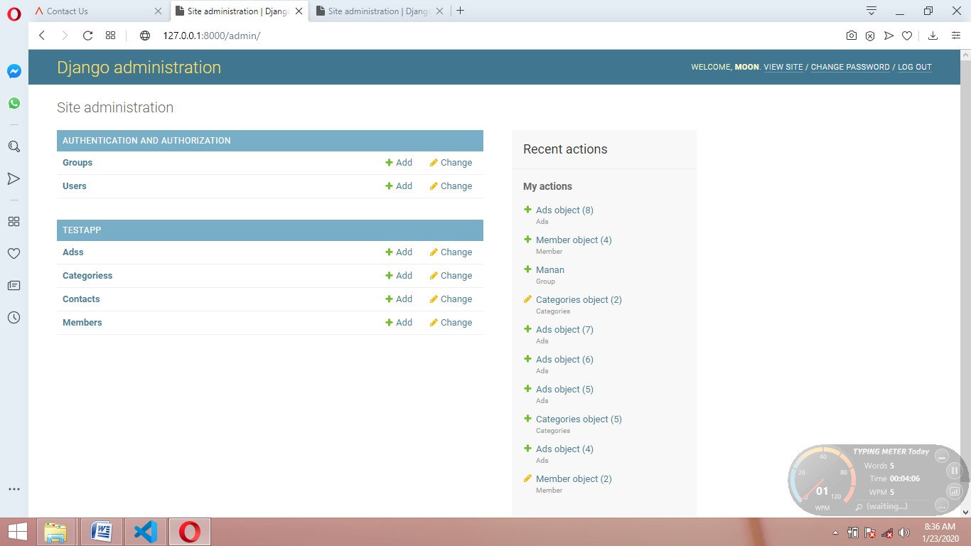

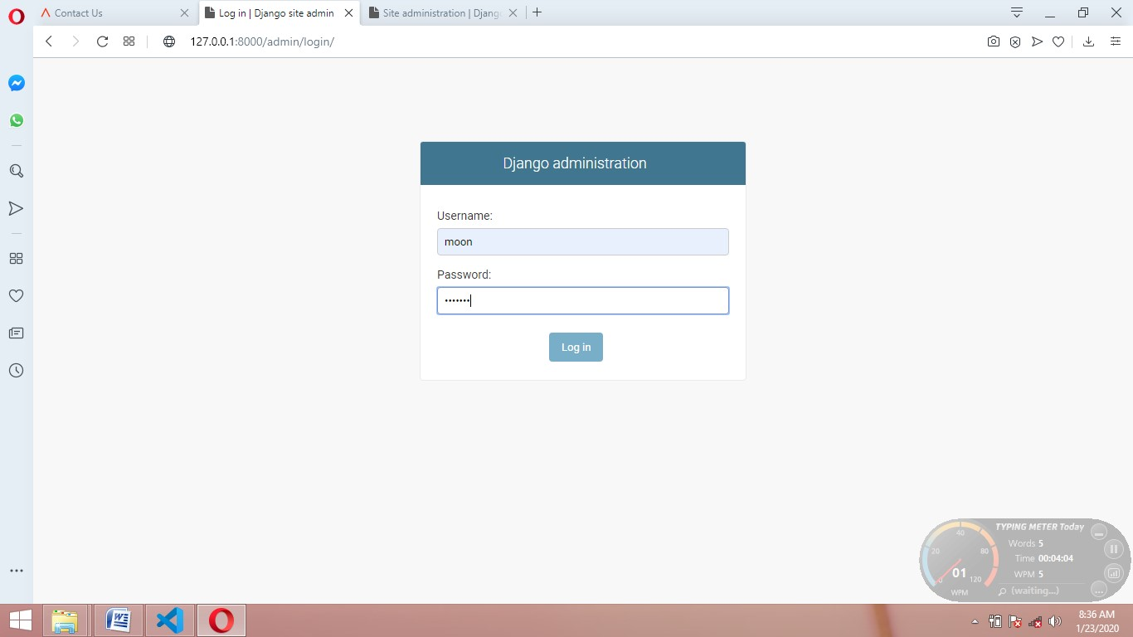

**2.**

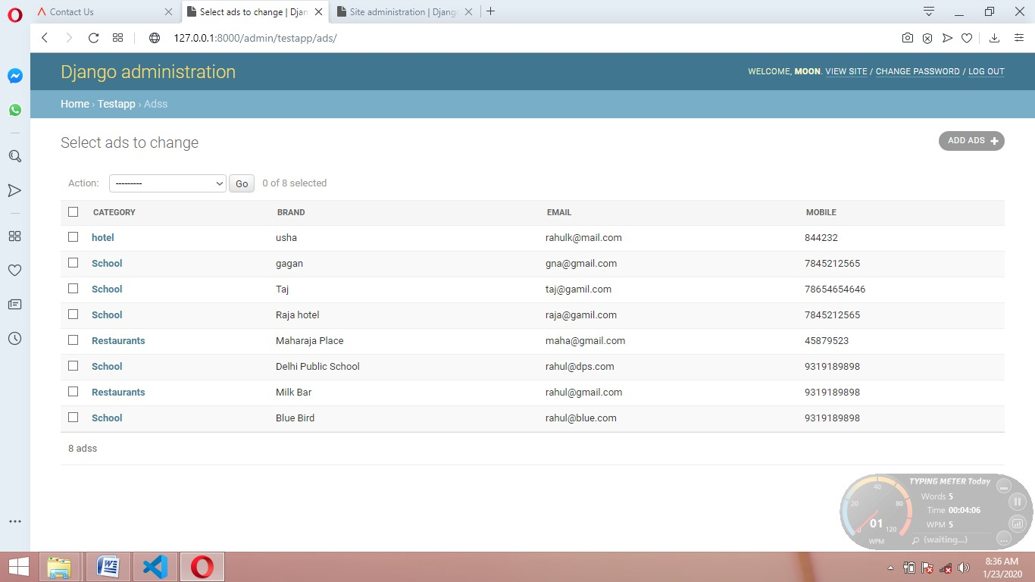

**3.**

**4.**

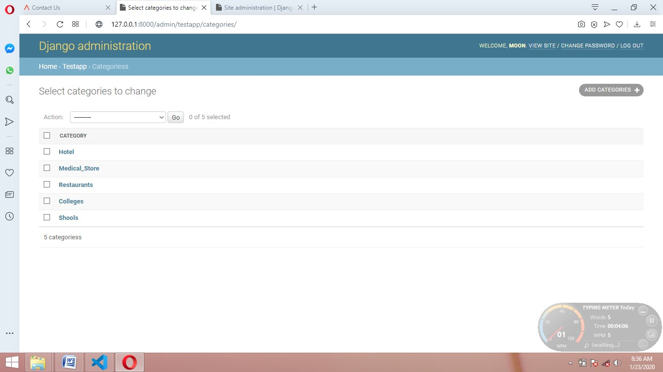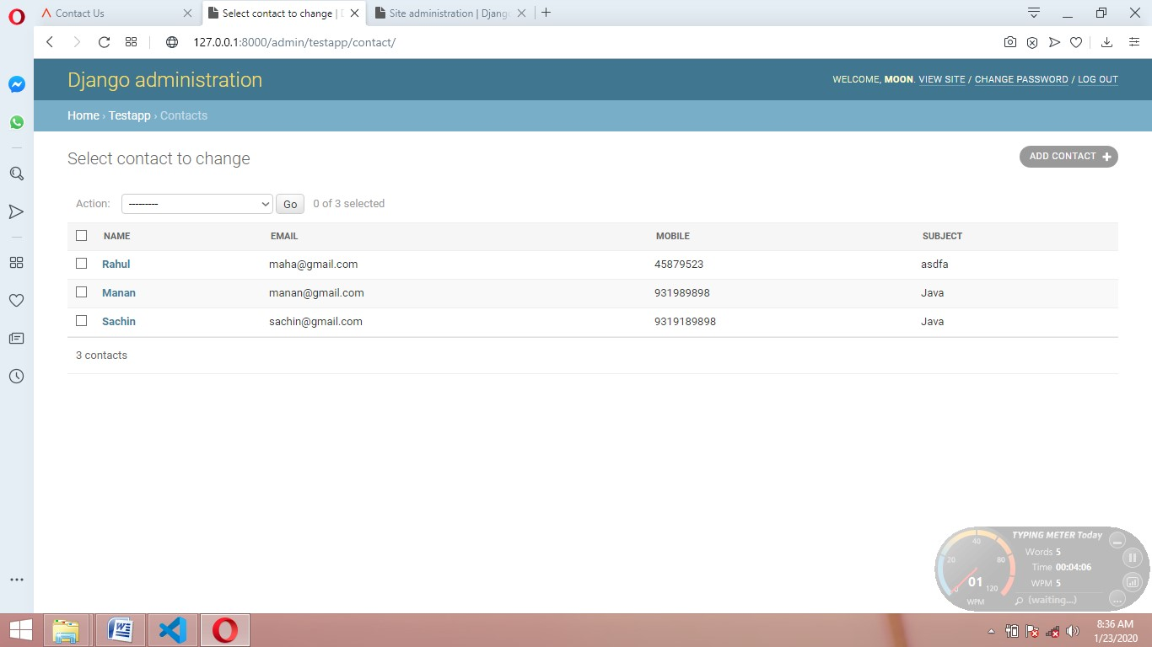

**5.**

**6.**

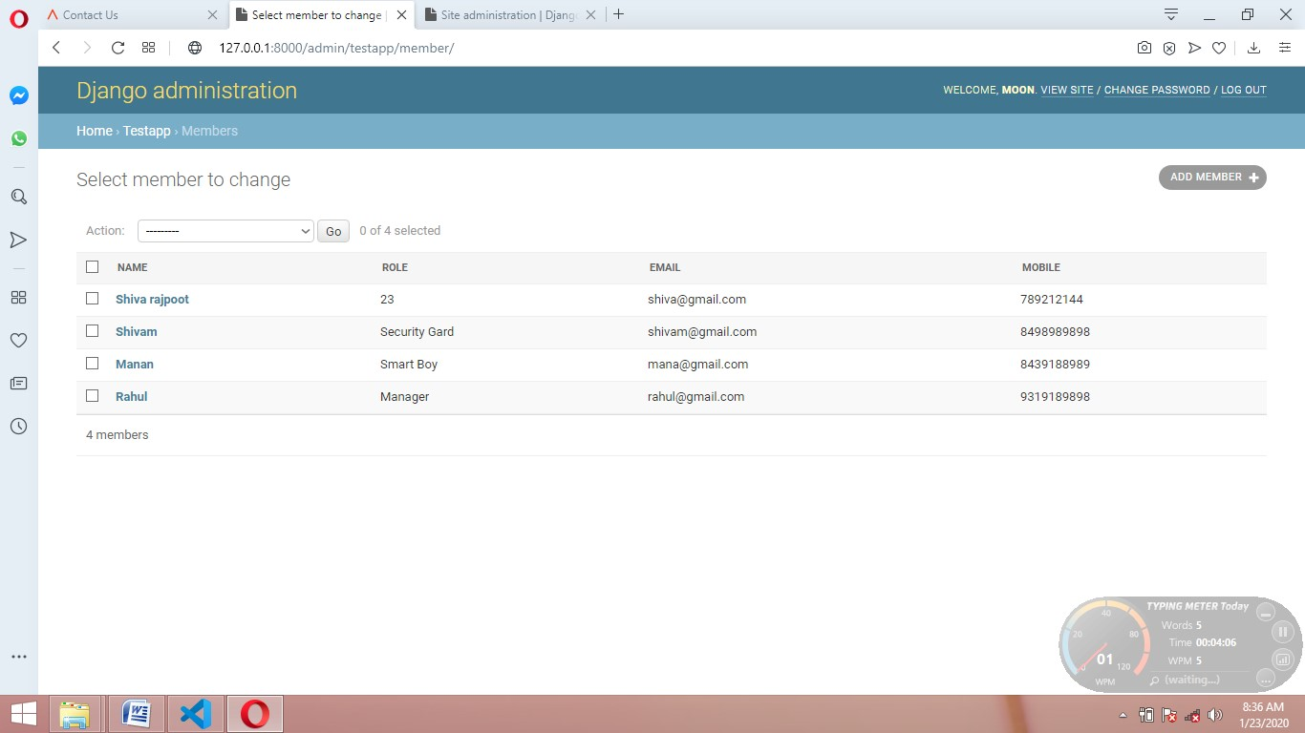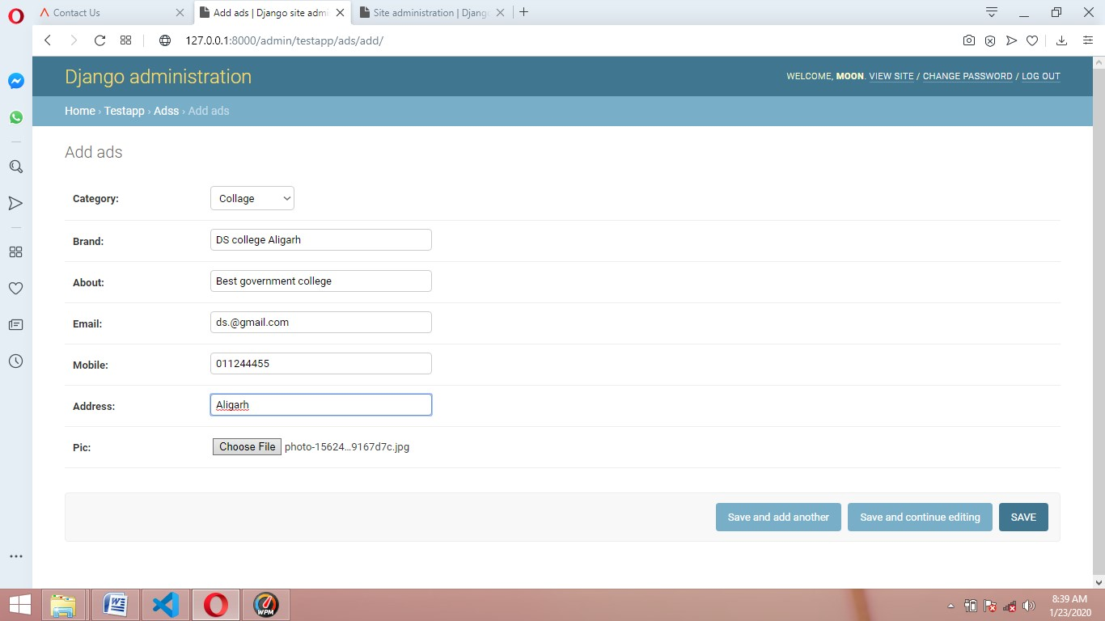

**CHAPTER 4**

**4.1 ER**

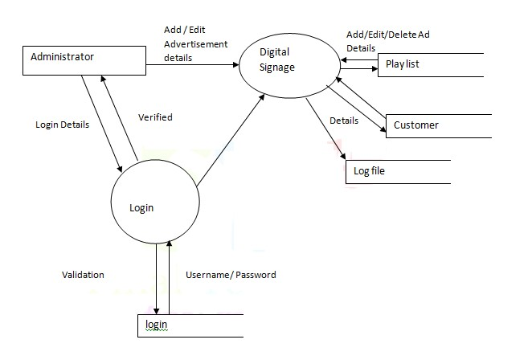

**4.2 DFD**

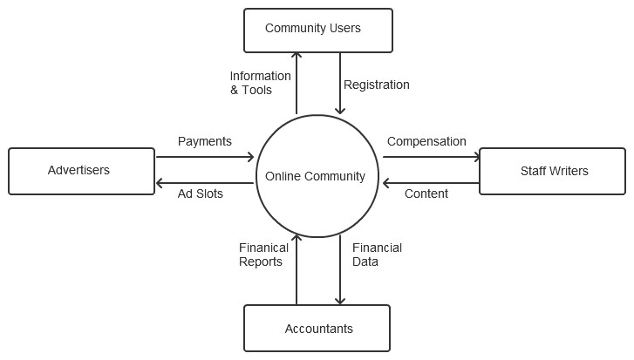

**CHAPTER 5**

## 5.1 Home

Home page is the first page of the website. When user go the website of advertisement management system this is the first page that will display to user.

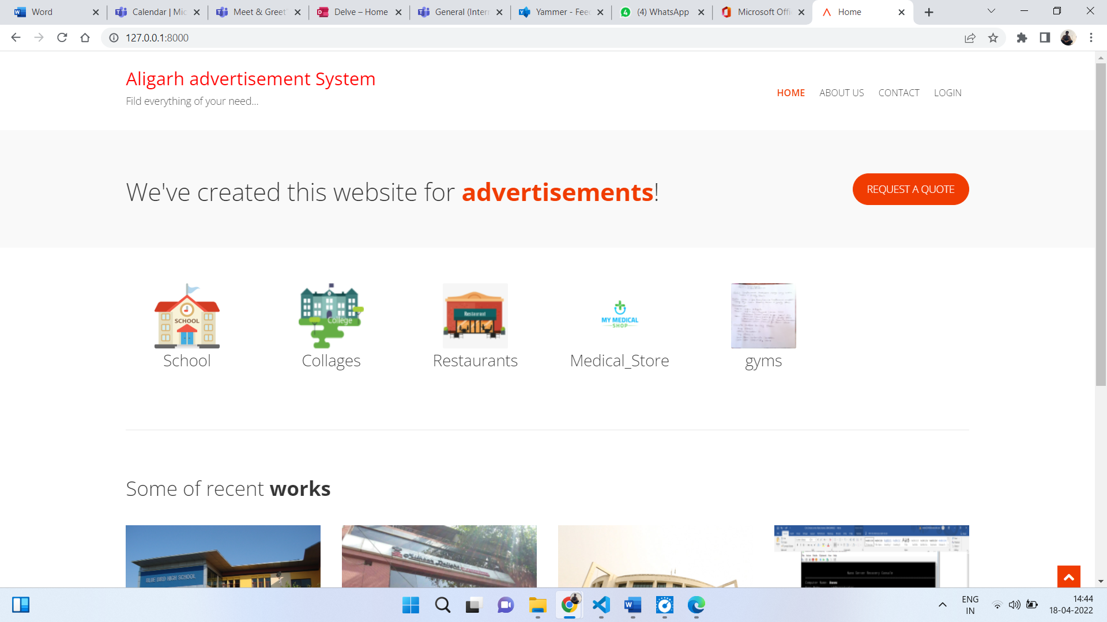

 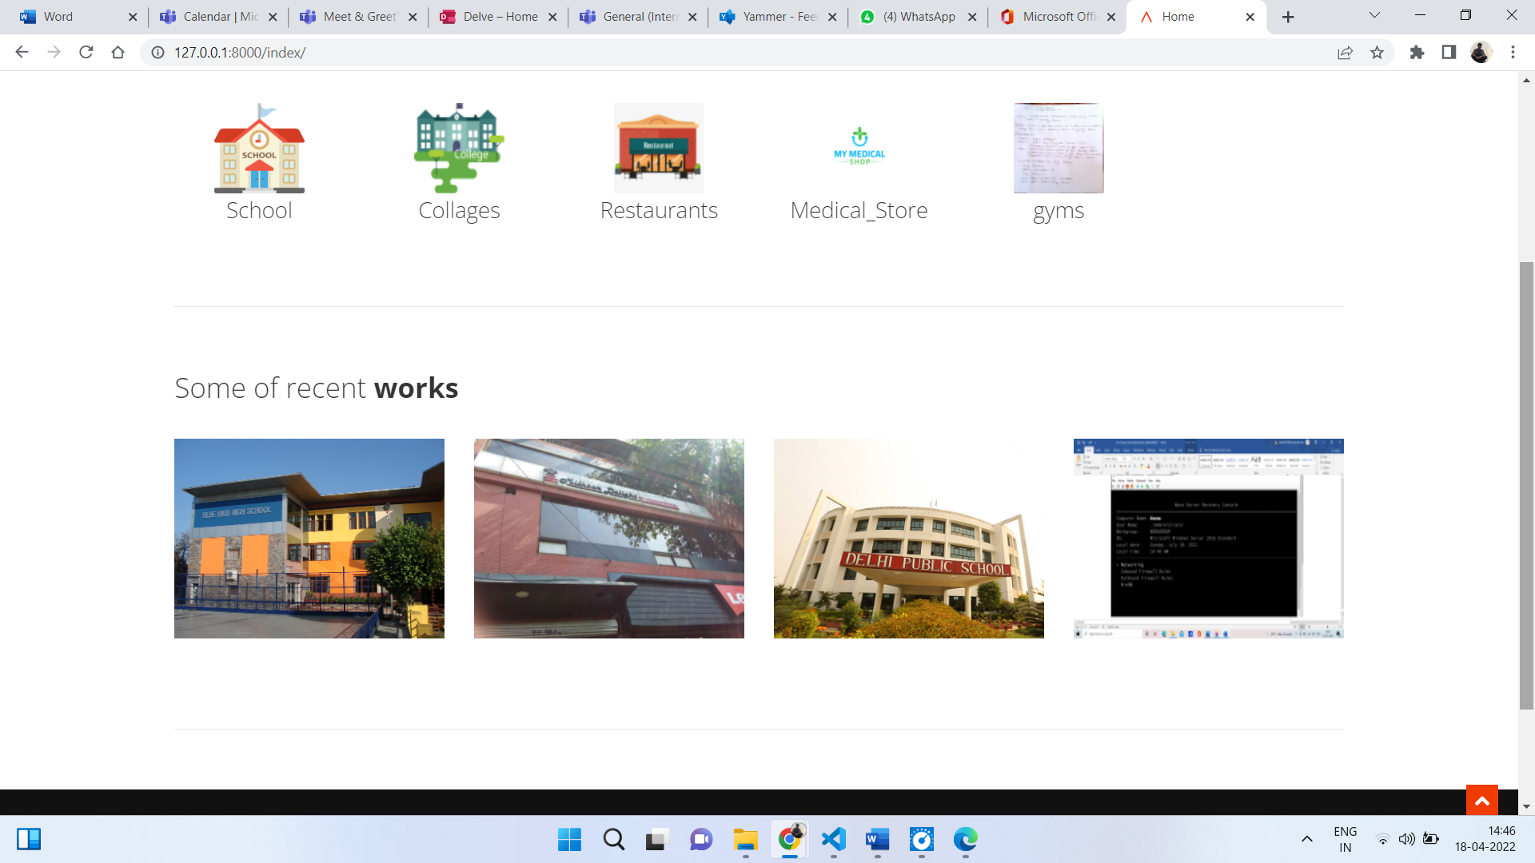

### **5.2About us**

User can navigate to about us page by clicking on about us link from home page.

On about us page we give the information about the organization like what we do and how we do. Different project organization has handled and aim of the organization.

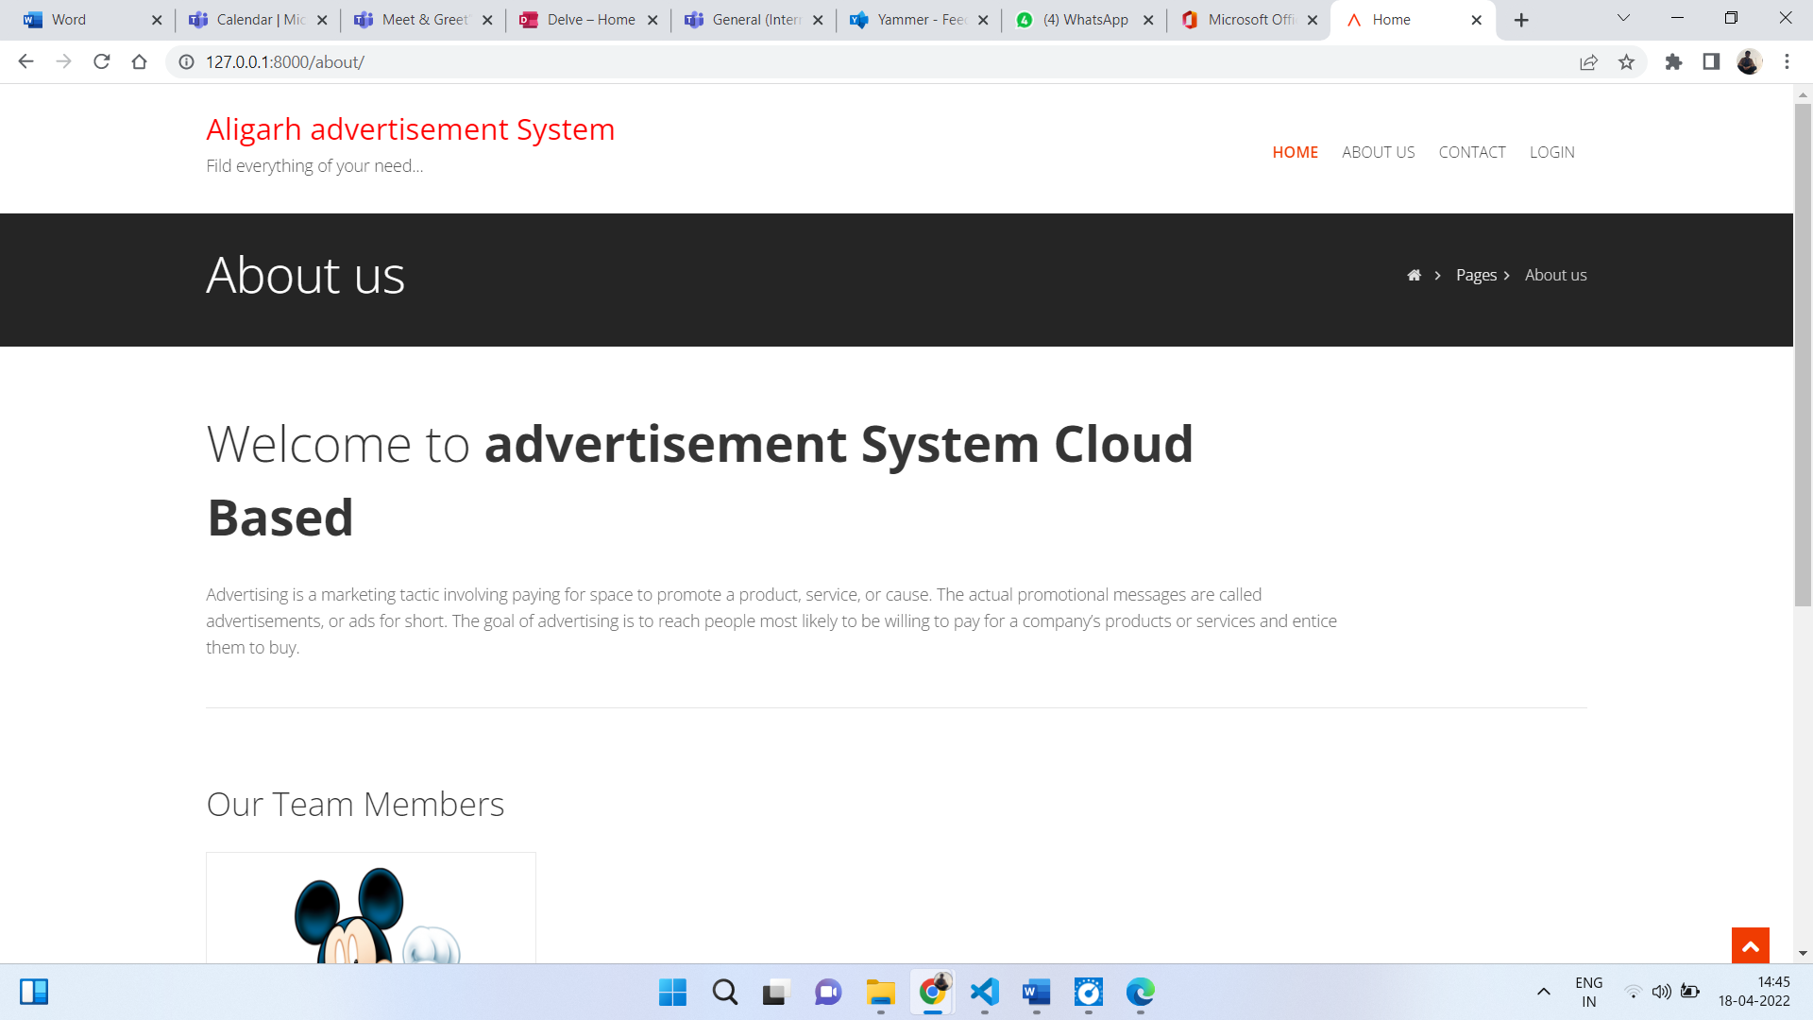

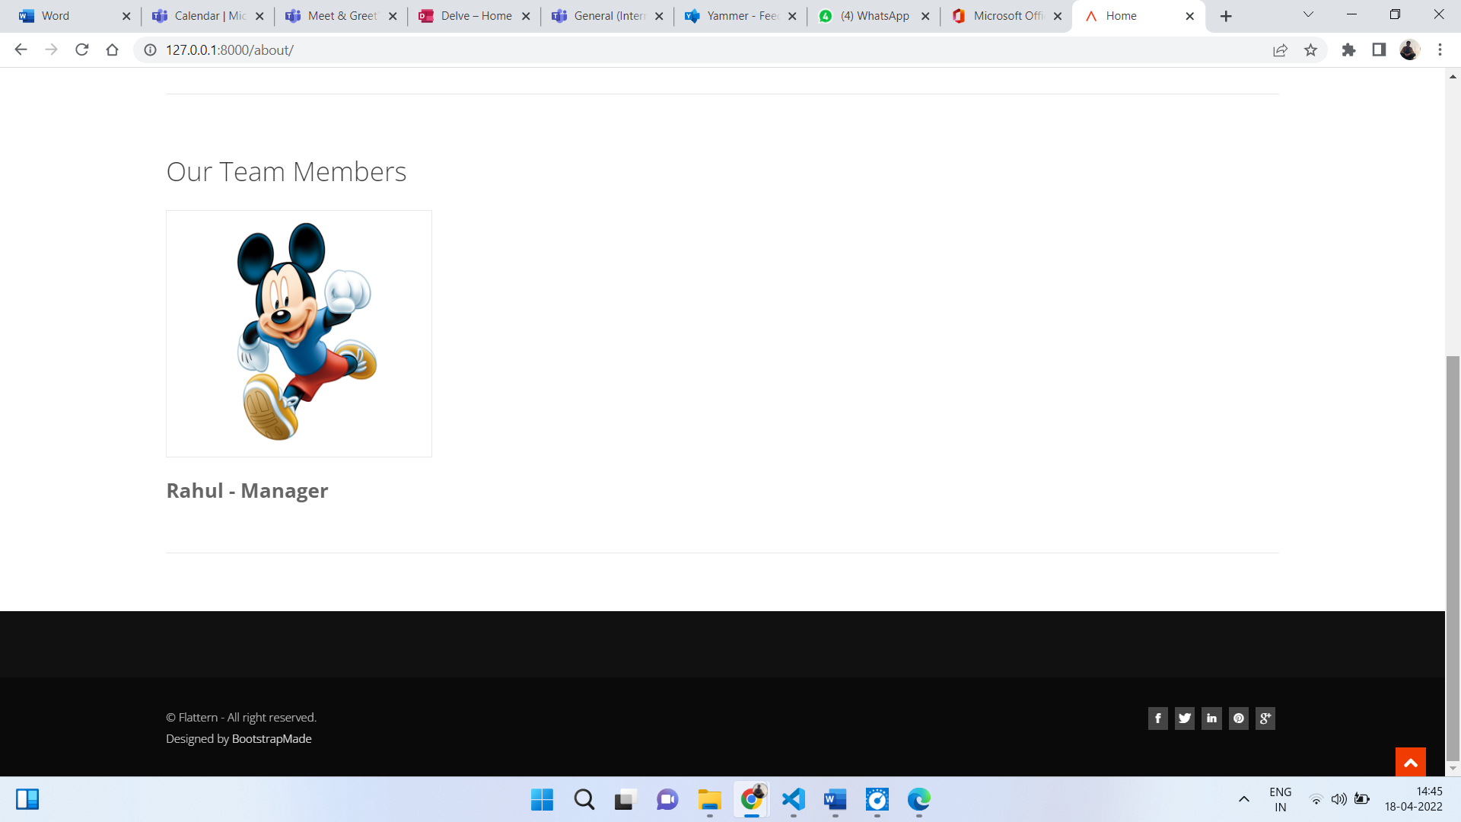

**5.3 Contact**

From contact us page user can get the address, phone number and email id of the organization.

Use can also send email to organization from contact us page.

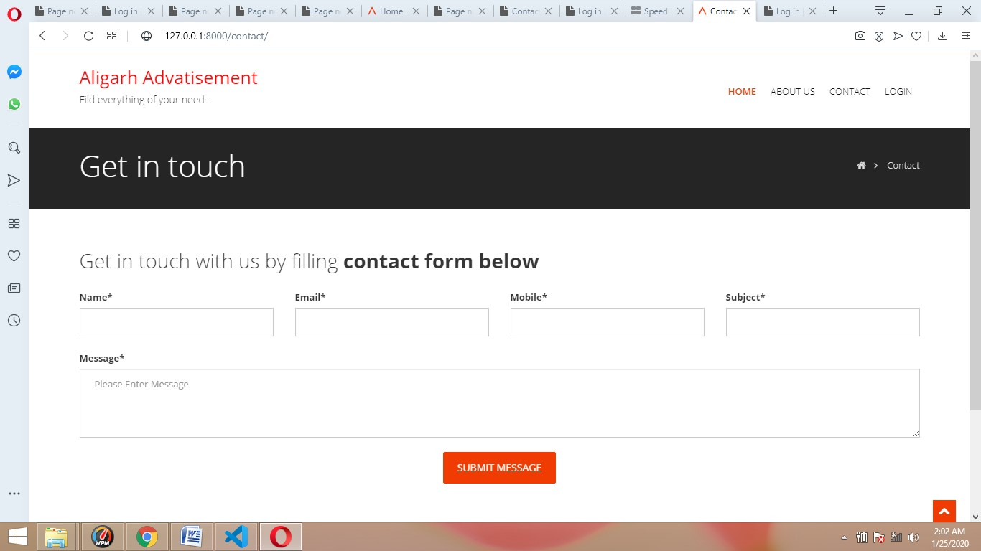

**5.4 DETAILS**

When user login to advertisement management system, profile page is displayed.

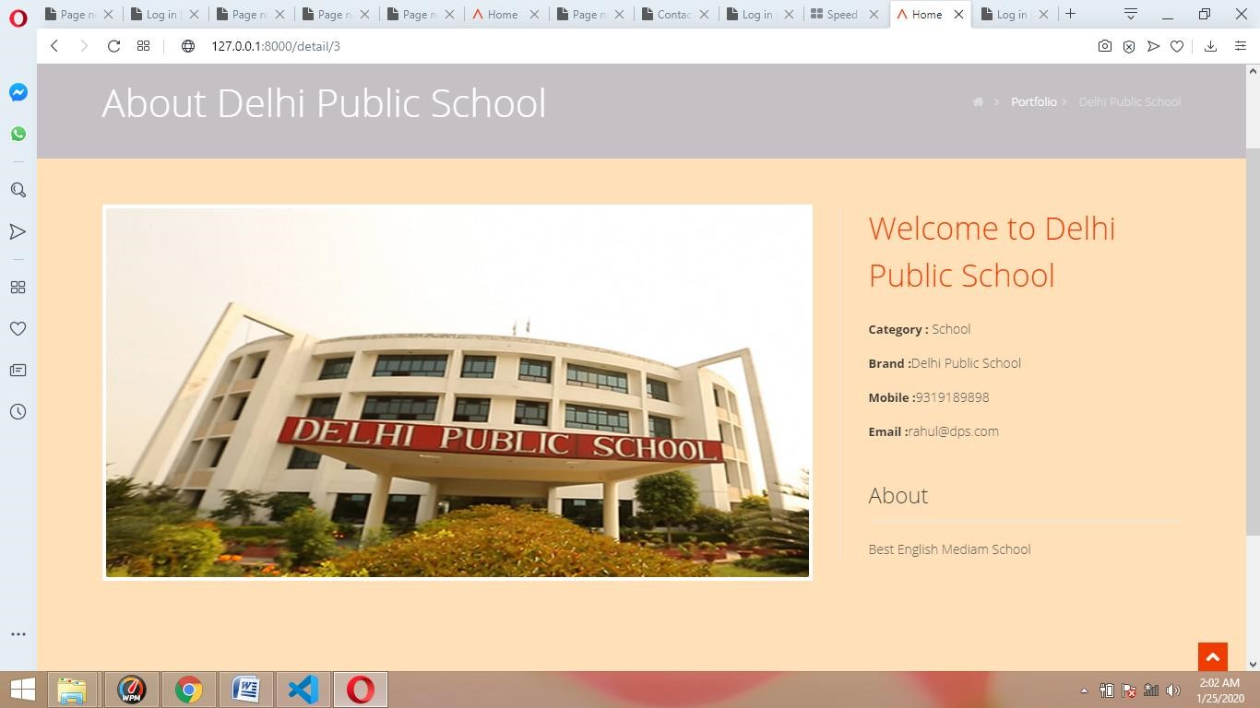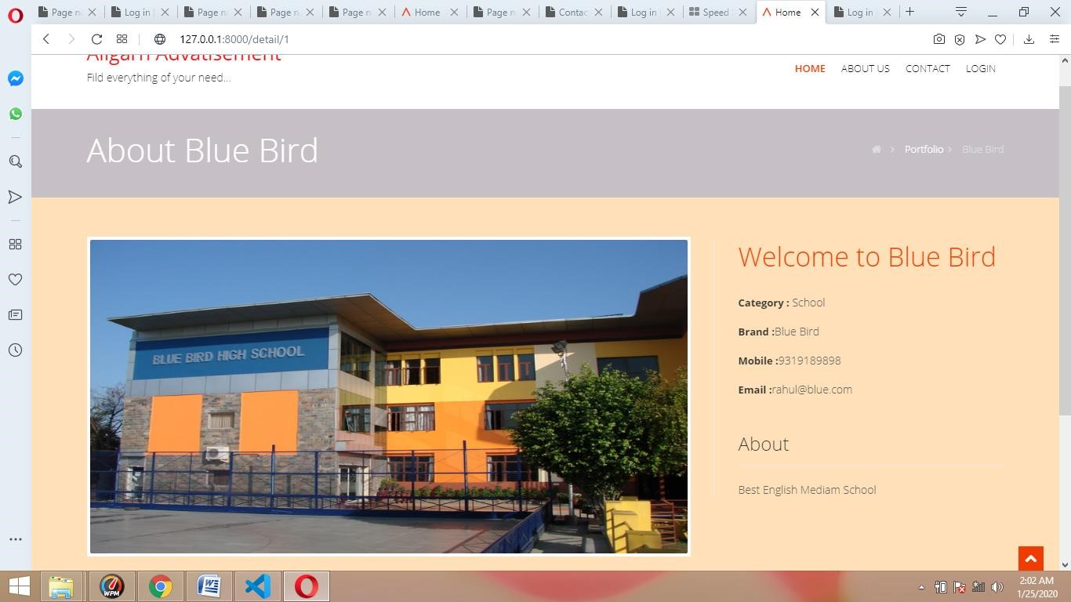

# CHAPTER 6

**TESTING**

It should be clear in mind that the philosophy behind is to find errors. Test cases are devised with this purpose in mind. A test case is a set of data that the system will process as normal input. There are two general strategies for testing Software: Code Testing and Specification Testing. In code Testing, The analyst develops the cases to execute every instructions and path in the program. Under specification testing, the analyst examines the program specification and then writes test data to determine how the program operates under specific conditions.

**Levels of tests**

**6.1 Unit Testing:**

In unit testing the analyst tests the programs making up a system. For this reason, unit testing is sometimes called program testing. Unit Testing gives stress on the modules independently of one another, to find errors. LIC Management system consists of modules to handle registration, modify or retrieve data and to respond to different types of inquiries or prints reports. The test cases needed for unit testing should exercise each condition and option.

### **6.2 Performance Testing**

Performance of the object detection system can be determined based on the system/application responsiveness under all kinds of load.

Performance testing in ReactJs framework is little different than traditional java/kotlin frameworks. The applications generate a lot of data which is saved in server and analyzed for immediate decisions. Hence they must be built for high performance and scalability. And to measure these two key attributes, it is important to understand the business value for which it is build i.e. in our case user location data.

**6.3 System Testing:** The important and essential part of the system development phase, after designing and developing the software is system testing. It can not be said that every program or system design is perfect and because of lack of communication between the user and the designer, some error is there in the software development.

System Testing Consists of the following five steps:

* Program Testing
* String Testing
* System Testing
* System Documentation
* User Acceptance testing.

➢

There are other 6 tests that fall under special category. They are:

* **Peak Load Test**: It determines whether the system will handle the volume of activities that occur when the system is at the peak of its processing demand.

* **Storage Testing**: It determines the capacity of the system to store transaction data on a disk or in other files.

* **Performance Time testing**; It determines the length of time system used by the system to process transaction data.

* **Recovery Testing**: This testing determines the ability of user to recover data or restart system after failure.

* **Procedure Testing:** It determines the clarity of documentation on operation and use of system by having users does exactly what manuals request.

**CHAPTER 7**

**Coding**

## Home/base.htm

{% load static %}

<!DOCTYPE html>

<html lang="en">

<head>

<meta charset="utf-8">

<title>{%block title_block %}Home{%endblock %}</title>

<meta name="viewport" content="width=devicewidth, initial-scale=1.0" />

<meta name="description" content="" />

<meta name="author" content="" />

### <!-- css -->

<link href="https://fonts.googleapis.com/css?family=No to+Serif:400,400italic,700|Open+Sans:300,400,600,700" re l="stylesheet">

<link href="{%static 'css/bootstrap.css' %}" rel="styl esheet" />

<link href="{%static 'css/bootstrapresponsive.css' %}" rel="stylesheet" />

<link href="{%static 'css/fancybox/jquery.fancybox.css ' %}" rel="stylesheet">

<link href="{%static 'css/jcarousel.css' %}" rel="styl esheet" />

<link href="{%static 'css/flexslider.css' %}" rel="sty lesheet" />

<link href="{%static 'css/slitslider.css' %}" rel="sty lesheet" />

<link href="{%static 'css/style.css' %}" rel="styleshe et" />

<!-- Theme skin --> <link id="tcolors" href="{%static 'skins/default.css' %}" rel="styl esheet" />

### <!-- boxed bg -->

<link id="bodybg" href="{%static 'bodybg/bg1.css' %}" rel="stylesheet" type="text/css" />

<!-- Fav and touch icons --> <link rel="apple-touch-iconprecomposed" sizes="144x144" href="{%static 'ico/appletouch-icon-144-precomposed.png' %}" /> <link rel="apple-touch-iconprecomposed" sizes="114x114" href="{%static 'ico/appletouch-icon-114-precomposed.png' %}" /> <link rel="apple-touch-iconprecomposed" sizes="72x72" href="{%static 'ico/appletouch-icon-72-precomposed.png' %}" /> <link rel="apple-touch-iconprecomposed" href="{%static 'ico/apple-touch-icon-57precomposed.png' %}" />

<link rel="shortcut icon" href="{%static 'ico/favicon. png' %}" />

<!- ======================================================= Theme Name: Flattern Theme URL: https://bootstrapmade.com/flatternmultipurpose-bootstrap-template/

### Author: BootstrapMade.com Author URL: https://bootstrapmade.com ====================================================== = -->

</head>

<body>

<div id="wrapper">

### <!-- toggle top area -->

<div class="hidden-top">

<div class="hidden-top-inner container">

<div class="row">

<div class="span12">

<ul>

<li><strong>We are available for any custo m works this month</strong></li>

<li>Main office: Springville center X264,

Park Ave S.01</li>

<li>Call us <i class="iconphone"></i> (123) 456-7890 - (123) 555-7891</li>

</ul>

</div>

</div>

</div>

</div>

### <!-- end toggle top area --> <!-- start header -->

<header>

<div class="container">

<!-- hidden top area toggle link -->

### <!-- end toggle link -->

<div class="row nomargin">

<div class="span12">

<div class="headnav">

</div>

<!-- Signup Modal -->

<!-- end signup modal --> <!-- Sign in Modal -->

### <!-- end signin modal -->

</div>

</div>

<div class="row">

<div class="span4">

<div class="logo">

<a href="/index"><p style="color: red;font

-weight: bolder;fontsize: 25px;">Aligarh Advatisement&Classfied</p></a>

<h1>Fild everything of your need...</h1>

</div>

</div>

<div class="span8">

<div class="navbar navbar-static-top">

<div class="navigation">

<nav>

<ul class="nav topnav">

<li class="dropdown active">

<a href="/index">Home </a>

</li>

<li>

<a href="/about">About Us </a>

</li>

<li>

<a href="/contact">Contact </a>

</li>

<li>

<a href="/admin" target='_blank'>L ogin </a>

</li>

</ul>

</nav>

</div>

### <!-- end navigation -->

</div>

</div>

</div>

</div>

</header>

### <!-- end header -->

{%block body_block %}

{%endblock %}

<footer>

<div id="sub-footer">

<div class="container">

<div class="row">

<div class="span6">

<div class="copyright">

<p>

<span>&copy; Aligarh Advatisement&clas sified - All right reserved.</span>

</p>

<div class="credits">

### <!--

All the links in the footer should r emain intact.

You can delete the links only if you purchased the pro version.

### Licensing information: https://boots trapmade.com/license/

Purchase the pro version with workin g PHP/AJAX contact form: https://bootstrapmade.com/buy/?

### theme=Flattern -->

Designed by <a href="#">Shivam kumar ,

Manan , Shivam Kumar</a>

</div>

</div>

</div>

<div class="span6">

<ul class="social-network"> <li><a href="#" dataplacement="bottom" title="Facebook"><i class="iconfacebook icon-square"></i></a></li> <li><a href="#" dataplacement="bottom" title="Twitter"><i class="icontwitter icon-square"></i></a></li> <li><a href="#" dataplacement="bottom" title="Linkedin"><i class="iconlinkedin icon-square"></i></a></li>

<li><a href="#" dataplacement="bottom" title="Pinterest"><i class="iconpinterest icon-square"></i></a></li> <li><a href="#" dataplacement="bottom" title="Google plus"><i class="icongoogle-plus icon-square"></i></a></li>

</ul>

</div>

</div>

</div>

</div>

</footer>

</div>

<a href="#" class="scrollup"><i class="icon-chevronup icon-square icon-32 active"></i></a>

### <!-- javascript ================================================== -> <!- Placed at the end of the document so the pages load fas ter -->

<script src="{%static 'js/jquery.js' %}"></script> <script src="{%static 'js/jquery.easing.1.3.js' %}"></ script>

<script src="{%static 'js/bootstrap.js' %}"></script> <script src="{%static 'js/jcarousel/jquery.jcarousel.m in.js' %}"></script>

<script src="{%static 'js/jquery.fancybox.pack.js' %}"

></script>

<script src="{%static 'js/jquery.fancyboxmedia.js' %}"></script>

<script src="{%static 'js/google-codeprettify/prettify.js' %}"></script>

<script src="{%static 'js/portfolio/jquery.quicksand.j s' %}"></script>

<script src="{%static 'js/portfolio/setting.js' %}"></ script>

<script src="{%static 'js/jquery.flexslider.js' %}"></ script>

<script src="{%static 'js/jquery.nivo.slider.js' %}"><

/script>

<script src="{%static 'js/modernizr.custom.js' %}"></s cript>

<script src="{%static 'js/jquery.bacond.min.js' %}"></script>

<script src="{%static 'js/jquery.slitslider.js' %}"></ script>

<script src="{%static 'js/animate.js' %}"></script>

### <!-- Template Custom JavaScript File -->

<script src="js/custom.js' %}"></script>

</body>

</html>

## About.htm

{%extends 'testapp/base.htm' %}

{% load static %}

{%block title_block %}

Home

{%endblock %}

{%block body_block %}

<section id="inner-headline">

<div class="container"> <div class="row">

<div class="span4">

<div class="inner-heading">

<h2>About us</h2>

</div>

</div>

<div class="span8">

<ul class="breadcrumb"> <li><a href="#"><i class="iconhome"></i></a><i class="icon-angle-right"></i></li> <li><a href="#">Pages</a><i class="iconangle-right"></i></li>

<li class="active">About us</li>

</ul>

</div>

</div> </div>

</section>

<section id="content">

<div class="container">

<div class="row">

<div class="span10">

<h2>Welcome to <strong>Aligarh Classified</s trong></h2>

<p>Advertising is a marketing tactic involvin g paying for space to promote a product, service, or cau se. The actual promotional messages are called advertise ments, or ads for short. The goal of advertising is to r each people most likely to be willing to pay for a compa ny’s products or services and entice them to buy.</p>

</div>

</div>

### <!-- divider -->

<div class="row">

<div class="span12">

<div class="solidline">

</div>

</div>

</div>

### <!-- end divider -->

<div class="row">

<div class="span12">

<h4>Our Team Members</h4>

</div>

{%for m in members %}

<div class="span3">

<img src="{{m.pic.url}}" alt="{{m.pic.url}

}" style="height: 250px;" class="img-polaroid" />

<div class="roles">

<p class="lead">

<strong>{{m.name}} -

{{m.role}}</strong>

</p>

</div>

</div>

{%endfor %}

</div>

### <!-- divider -->

<div class="row">

<div class="span12">

<div class="solidline">

</div>

</div>

</div>

### <!-- end divider -->

</div>

</section>

{%endblock %}

## contact.htm

{%extends 'testapp/base.htm' %}

{% load static %}

{%load crispy_forms_tags %}

{%block title_block %}

Contact Us

{%endblock %}

{%block body_block %}

### <!-- end header -->

<section id="inner-headline">

<div class="container">

<div class="row">

<div class="span4">

<div class="inner-heading">

<h2>Get in touch</h2> </div>

</div>

<div class="span8">

<ul class="breadcrumb"> <li><a href="#"><i class="iconhome"></i></a><i class="icon-angle-right"></i></li>

<li class="active">Contact</li>

</ul>

</div>

</div> </div>

</section>

<section id="content">

<div class="container">

<div class="row">

<div class="span12">

<h4>Get in touch with us by filling <strong> contact form below</strong></h4>

{{msg}}

<form method="post" role="form" class="cont actForm">

{%csrf_token %}

<div id="sendmessage">Your message has bee n sent. Thank you!</div>

<div id="errormessage"></div>

<div class="row">

<div class="span3 form-group">

{{form.name|as_crispy_field}}

</div>

<div class="span3 form-group"> {{form.email|as_crispy_field}}

</div>

<div class="span3 form-group">

{{form.mobile|as_crispy_field}}

</div>

<div class="span3 form-group">

{{form.subject|as_crispy_field}}

</div>

<div class="span12 margintop10 formgroup">

{{form.message|as_crispy_field}}

<p class="text-center">

<button class="btn btn-large btntheme margintop10" type="submit">Submit message</button>

</p>

</div>

</div>

</form>

</div>

</div> </div>

</section>

{%endblock %}

**CHAPTER 8**

**FUTURE ENHANCEMENT OF THE PROJECT**

As Most of the business documentation works through Computer therefore this software is useful for OAMS (Advertisement System Cloud based). The purpose of computerization is basic need for organizations at this time because it is helpful to decrease the lot of mistakes which are comes through manual work and reduce the calculation graph, that’s why such modification & improvement is nothing but Computerization in India. Software Engineers have been trying various tools, methods and procedures to control the process of software development in order to build high quality software with high productivity. This method provides ?how it is? for building the software while the tools provide automated or semi automated support for the methods. They are used in all stages of software development process, namely, planning, analysis, design, development and maintenance. The software development procedure integrates the methods and tools together and enables rational and timely development of the software system.

**References**

1. https:/[/www](http://www.boltiot.com/).[boltiot.com/](http://www.boltiot.com/)
2. Albugmi, Ahmed and Alassafi, Madini and Walters, Robert and Wills, Gary , “data security in cloud computing ” , 2016
3. Ruben D. Hernández, Robinson Jiménez Moreno and Mauricio Mauledeoux , “ Smart Bulb for IoT” , 2018
4. Satya ShahAikaterini Ververi , “ Evaluation of Internet of Things (IoT) and its impacts on Global Supply Chains” ,2018
5. MEHRSHAD HOSSEINI OMID SAHRAGARD , “ AWS Lambda Language Performance” , 2018
6. Rob van Kranenburg and Alex Bassi , “ IoT Challenges” , 2017
7. NATHAN ROEHL , “ Cloud Based IoT Architecture” , 2019
8. Haowei Jiang , “ Ultra-Low-Power Sensors and Receivers for IoT Applications”

,2019

1. Dr. Gurudev Singh,Prince Jain , Lalit kumar , “ Cloud Implementation and Cloud Integration” , 2020
2. Saima Zafar , Ghosia Miraj , Rajaa Baloch , Danish Murtaza, Khadija Arshad ,” An

IoT Based RealTime Environmental Monitoring System Using Arduino and Cloud Service ” , 2018

**CONCLUSION**

The typical approach to advertising in mass media usually involves broadcasting simple, standardized messages to a passive, captive audience. However, the implications of communicating with active media users on the Web, as opposed to utilizing traditional methods, are vast The power of recipients cannot be underestimated. In the information pull context of the Web, where consumers have immense choice and control over media options, the decision whether to visit an advertising website, how long to stay there, and what parts of it to view, belong to the customer. If a site is to leave a positive impression on the customer, it needs to provide some kind of value in return for the time and money the customer spends to visit the site.

ISSN: 2582-3930

**Volume: 06 Issue: 03 | March - 2022**

**International Journal of Scientific Research in Engineering and Management (IJSREM)**



Advertisement System Cloud Based

# Shivam Kumar

School of Computer Science and IT, Jain (Deemed-to-be University), Bangalore, Karnataka, INDIA

# Dr. Bhuvana

School of Computer Science and IT, Jain (Deemed-to-be University), Bangalore, Karnataka, INDIA

# ABSTRACT :

The Advertising System Project is a complete online solution for advertisers who want to advertise their products on online media or websites. This project is developed for users who want to manage their online advertising from one place. This website is useful for employees and managers of advertising agencies to manage ads and view reports. This system provides a complete service for advertisers to present their products and services to the online marketplace. The advertising system will give the solution to all the problems related to online marketing. In this system, the user can create ads and also choose the website where he wants to show his ads online.

**© 2022, IJSREM**

**|** [www.ijsrem.com](http://www.ijsrem.com/)

**DOI: 10.55041/IJSREM12049**

|

Page 45

ISSN: 2582-3930

**Volume: 06 Issue: 03 | March - 2022**

**International Journal of Scientific Research in Engineering and Management (IJSREM)**



# INTRODUCTION

Advertising is very necessary to market or promote the product of a particular product. Advertising can be done online through radio, television, social networking sites to get good promotion. An online advertising management system is an application that takes care of the maintenance of the advertisements that customers provide to the company. There will be many customers with different listings for a particular business. Maintaining all the data with pen and paper is a tedious task.

# Survey Outcomes

A number of cloud partners, including Amazon's Elastic Compute Cloud and IBM's SmartCloud, are changing the course of exceptional organizations since they are taking control of IT structures and offering online cloud services.Getting it in the present is really not a difficult task.As a general matter, you can purchase or rent it on the web and use the APIs provided by cloud providers to dispatch, re-attempt and shut down the virtual pictures.With cloud-based online affiliations, one of the most prominent advantages is the ability for customers to create, change, and exchange digital pictures with various customers.It is now possible to store, share, and archival objects of many different types on the cloud.The high level management interface hides system implementation details and performance data, however, while guaranteeing ease of use.An experimental study is presented here that examines how the cloud-to-user network performs when it is perceived by a set of home users throughout the globe using the Amazon S3 cloud-storage service.Load balancing in cloud computing data centers has been a major challenge in recent years.The authors presented a survey on the current

**© 2022, IJSREM**

**|** [www.ijsrem.com](http://www.ijsrem.com/)

**DOI: 10.55041/IJSREM12049**

|

Page 46

load balancing techniques and solutions that have been proposed only for cloud computing

ISSN: 2582-3930

**Volume: 06 Issue: 03 | March - 2022**

**International Journal of Scientific Research in Engineering and Management (IJSREM)**



environments.Cloud load balancing mechanisms can be categorized into three main groups based on their designing perspectives: general algorithm- based approaches, architectural-based approaches, and AIbased approaches. Yet, cloud paradigm comes into play to assist the use of such applications, but these are in favor of data access beyond single key-value pairs.Therefore, they are dependent on traditional databases.Therefore, there's a gap between db systems from the past and those of today.There is a need to close this gap if we wish to ensure that the cloud can support all types of applications now and in the future.AuthStore enables users to securely reuse passwords at multiple providers and for secure data encryption.Only one service is needed for AuthStore to operate, that is, a service provider.It is necessary for users to remember only username and password in order to authenticate and gain access to encrypted data.Passwords can be protected using key stretching using AuthStore, putting control in the hands of users.Cloud computing is a complex concept that anyone can get lost in.However, cloud computing has a double edge just like any other technology.Technology promises lightning-fast speeds, a large variety of apps to choose from, and seemingly limitless storage space on one hand.There are various security threats associated with shared spaces such as compromise of confidential information, degradation of data integrity, and non-availability of data.

# CONCLUSION & FUTURE SCOPE

The typical approach to advertising in mass media usually involves broadcasting simple, standardized messages to a passive, captive audience. However, the implications of communicating with active media users on the Web, as opposed to utilizing traditional methods, are vast The power of recipients cannot be underestimated. In the information pull context of the Web, where consumers have immense choice and control over media options, the decision whether to visit an advertising website, how long to stay there, and what parts of it to view, belong to the customer. If a site is to leave a positive impression on the customer, it needs to provide some kind of value in return for the time and money

the customer spends to visit the site.

**© 2022, IJSREM**

**|** [www.ijsrem.com](http://www.ijsrem.com/)

**DOI: 10.55041/IJSREM12049**

|

Page 47

ISSN: 2582-3930

**Volume: 06 Issue: 03 | March - 2022**

**International Journal of Scientific Research in Engineering and Management (IJSREM)**



# References

1. https:/[/www](http://www.boltiot.com/).[boltiot.com/](http://www.boltiot.com/)
2. Albugmi, Ahmed and Alassafi, Madini and Walters, Robert and Wills, Gary , “data security in cloud computing ” , 2016
3. Ruben D. Hernández, Robinson Jiménez Moreno and Mauricio Mauledeoux , “ Smart Bulb for IoT” , 2018
4. Satya ShahAikaterini Ververi , “ Evaluation of Internet of Things (IoT) and its impacts on Global Supply Chains” ,2018
5. MEHRSHAD HOSSEINI OMID SAHRAGARD , “ AWS Lambda Language Performance” , 2018
6. Rob van Kranenburg and Alex Bassi , “ IoT Challenges” , 2017
7. NATHAN ROEHL , “ Cloud Based IoT Architecture” , 2019
8. Haowei Jiang , “ Ultra-Low-Power Sensors and Receivers for IoT Applications”

,2019

1. Dr. Gurudev Singh,Prince Jain , Lalit kumar , “ Cloud Implementation and Cloud Integration” , 2020
2. Saima Zafar , Ghosia Miraj , Rajaa Baloch , Danish Murtaza, Khadija Arshad ,” An

IoT Based RealTime Environmental Monitoring System Using Arduino and Cloud Service ” , 2018

1. Mohammad Riyaz Belgaum, Safeeullah Soomro, Zainab Alansari, Muhammad Alam,Shahrulniza Musa,Mazliham Mohd Su’ud , “ Challenges: Bridge between Cloud and IoT” , 2018

**© 2022, IJSREM**

**|** [www.ijsrem.com](http://www.ijsrem.com/)

**DOI: 10.55041/IJSREM12049**

|

Page 48

ISSN: 2582-3930

**Volume: 06 Issue: 03 | March - 2022**

**International Journal of Scientific Research in Engineering and Management (IJSREM)**



**© 2022, IJSREM**

**|** [www.ijsrem.com](http://www.ijsrem.com/)

**DOI: 10.55041/IJSREM12049**

|

Page 49